EXPERIMENT15

DeterminationandplottingofInductance(i)Self-inductanceand Mutual inductance ofcurrent carrying coil, (ii) solenoid and toroidwithdifferent(a)lengthand(b)circumferentialarea.

Aim:
TodetermineandplotInductance(i)Self-inductanceandMutual inductance of current carrying coil, (ii) solenoid and toroid with different(a)lengthand(b)circumferentialarea.
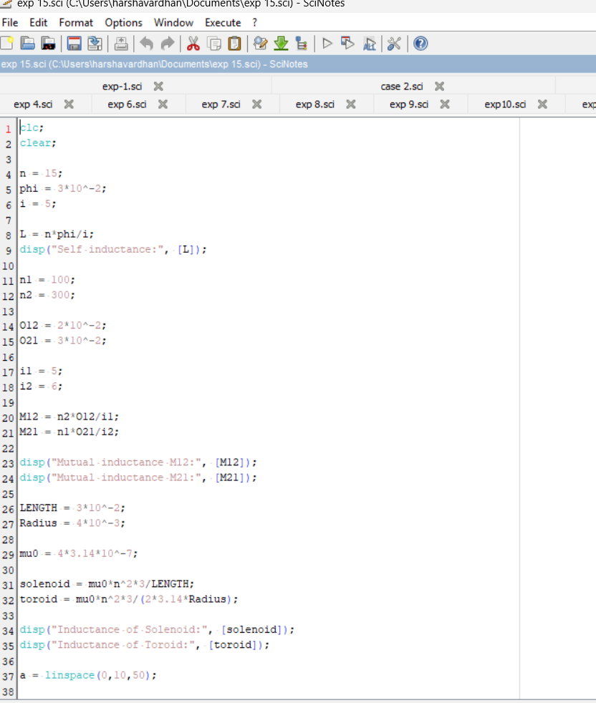
Softwarerequired: SCILABversion6.0.1. Program:

Output:

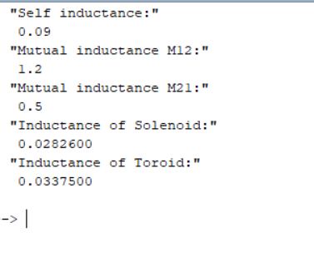

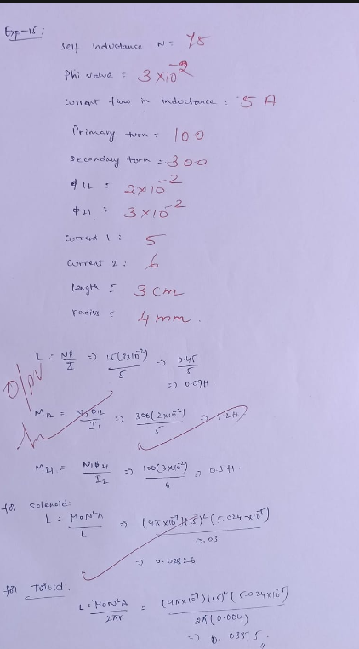
Theoreticalcalculations:

Result:
Thus determination and plotting of Inductance ,Self-inductance, Mutualinductanceofcurrentcarryingcoil,solenoidandtoroidwith different(a)lengthand(b)circumferentialareaareperformedand verifiedsuccessfully.

